MAKING SAFETY PERSONAL
Try one of the following activities as part of Safe + Sound Week, at safety meetings, or at any workplace gatherings throughout the year. These engaging activities can increase participation in safety and health programs by getting managers and workers thinking about and discussing what safety on the job means to them.
Why Safety Matters
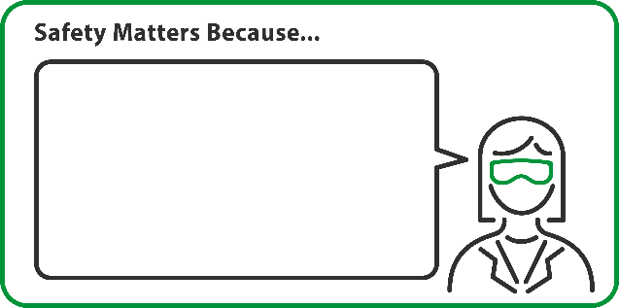
Initiate conversations about safety by offering managers and workers ways to think about their motivations for contributing to a safe and healthy workplace. Have everyone fill out a word bubble describing why safety matters to them. Read and discuss during an all-hands meeting or post in a visible place. Copy, cut, and distribute the graphics on pages 2 and 3 if filling-in text by hand, or paste one or more of the graphics into a Word document if inserting text electronically.
Why Safety Matters example
My co-workers and I are a team. If someone gets hurt, we all end up hurting.
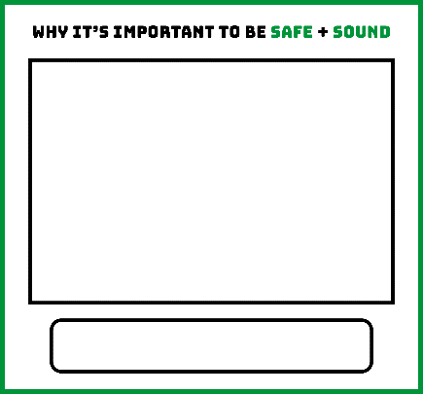

Framing Safety
I want to see my grandchildren grow up.
Begin framing safety and health conversations by asking managers and workers to share a photo that depicts why it’s important for them to come home safely from work each day. Display photos in a visible place or scan and post on your intranet site to remind managers and workers about the importance of safety. Copy and distribute the graphics on pages 4 and 5 to frame photos and write in a small description about why the image was chosen. Photos can be inserted electronically with the instructions listed in the graphic or they can be printed out and taped to the inside of the frame.
Framing Safety example
For more workplace health and safety activity ideas, visit www.osha.gov/safeandsoundweek.
Businesses can share their commitment to safety by emailing graphics to safeandsoundcampaign@dol.gov or post on social media using the hashtag #SafeAndSound2018. These could be featured on the Campaign website or in Campaign communications.
Disclaimer: This document was created by the Safe + Sound Campaign organizers, OSHA, AIHA, ASSP, CPWR, NIOSH, NSC, and VPPPA. The Safe + Sound Campaign organizers do not necessarily endorse or sanction the company-specific statements in this document.

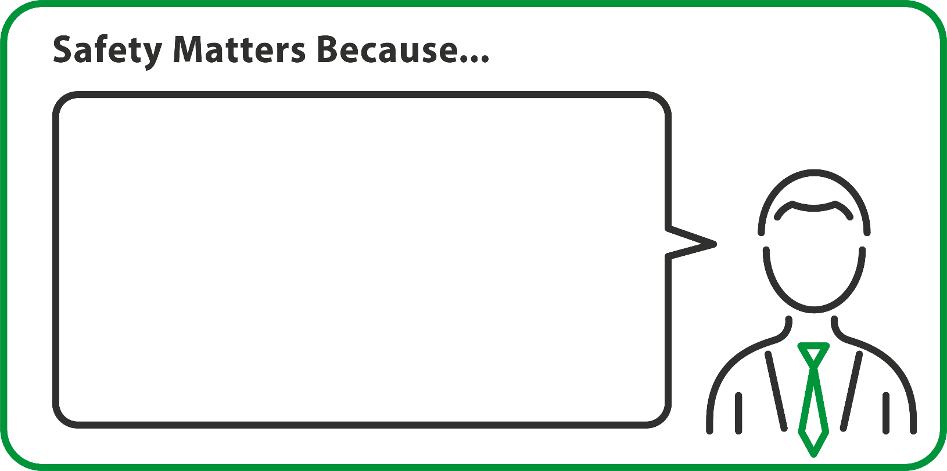
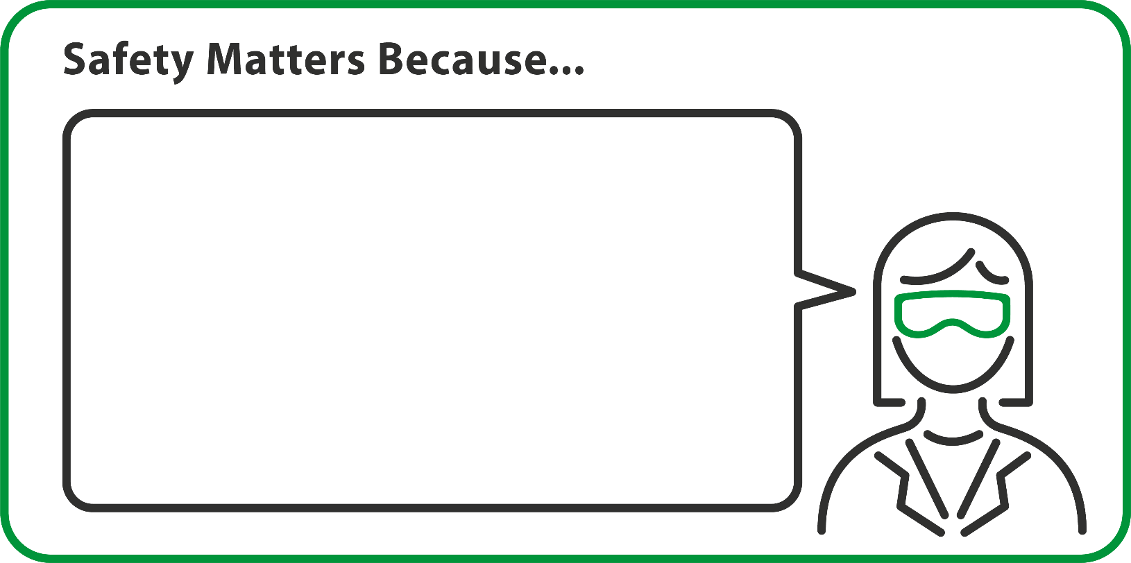
Use this box to add a brief description of why safety matters to you.
Delete this text box if you are going to print this document and handwrite your description.

Use this box to add a brief description of why safety matters to you.
Delete this text box if you are going to print this document and handwrite your description.

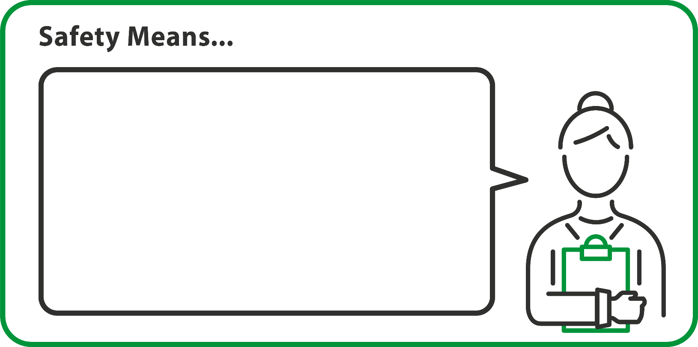
Use this box to add a brief description of what safety means to you.
Delete this text box if you are going to print this document and handwrite your description.

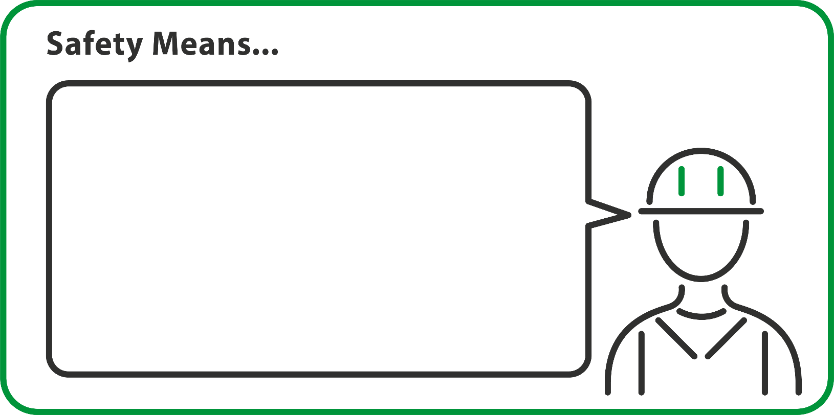
Use this box to add a brief description of what safety means to you.
Delete this text box if you are going to print this document and handwrite your description.


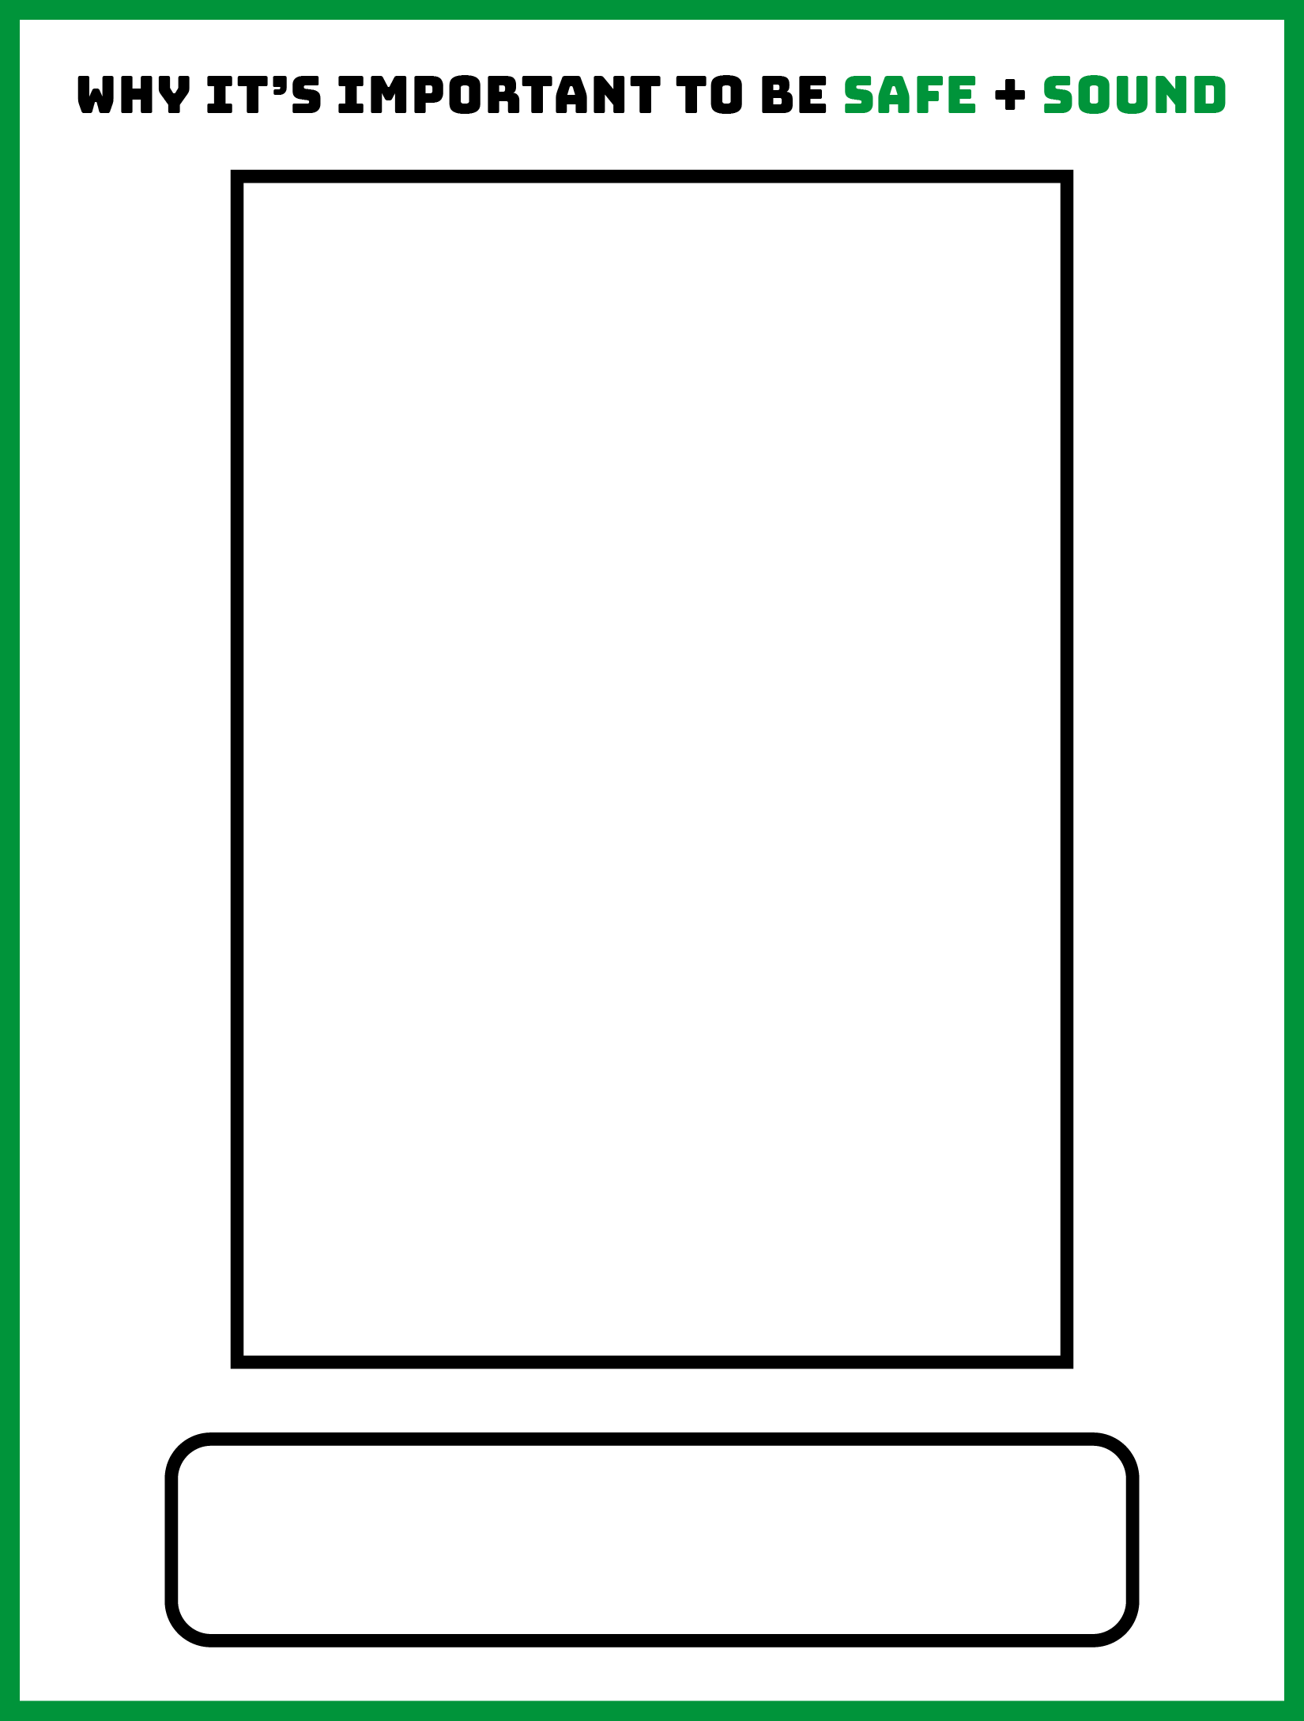
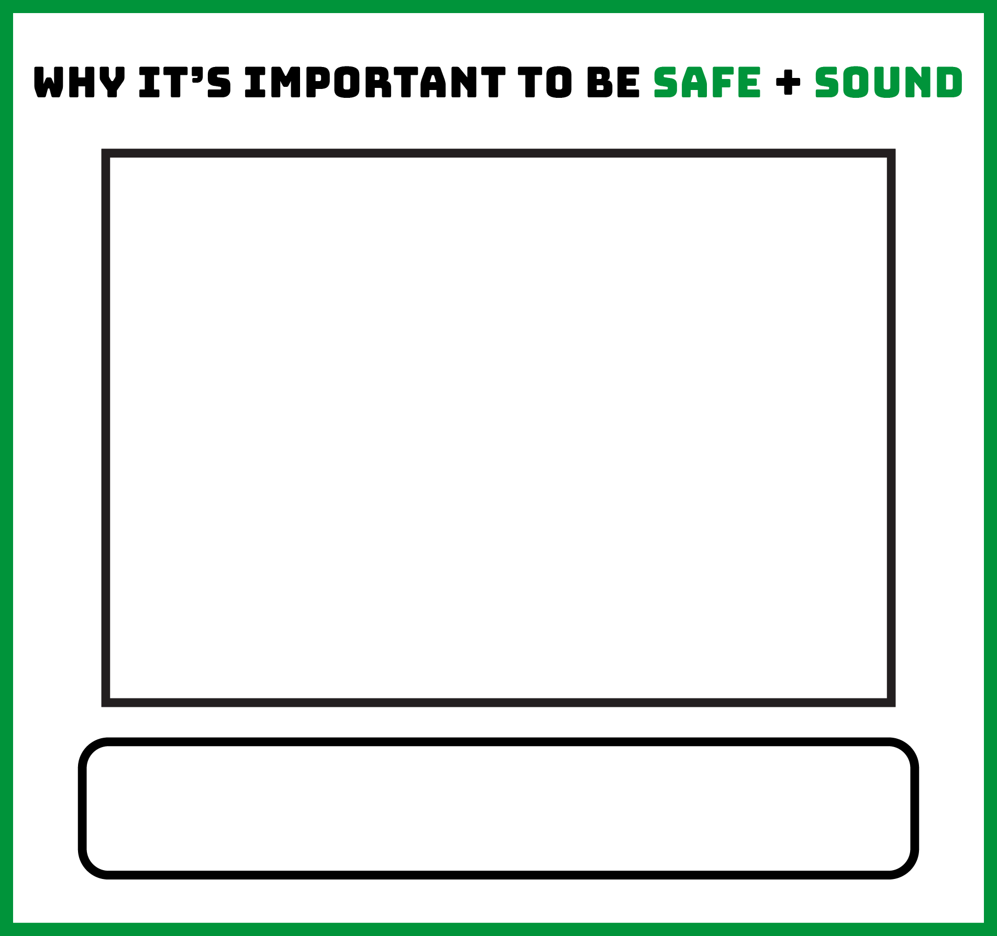

Use this box to add a brief description of your photo. Delete this text box if you are going to print this document and handwrite your description.
Use this box to add a brief description of your photo. Delete this text box if you are going to print this document and handwrite your description.

